**LAB # 04**



**Spring 2024**

**Data Structures and Algorithm**

Submitted by: **Hassan Zaib Jadoon**

Registration No.: **22PWCSE2144**

Class Section: **A**

“On my honor, as student of University of Engineering and Technology, I have neither given nor received unauthorized assistance on this academic work.”

Submitted to:

**Engr. Usman Mailk**

Department of Computer Systems Engineering

University of Engineering and Technology, Peshawar

**Problem 1:**

**Solution:**

**Code:**

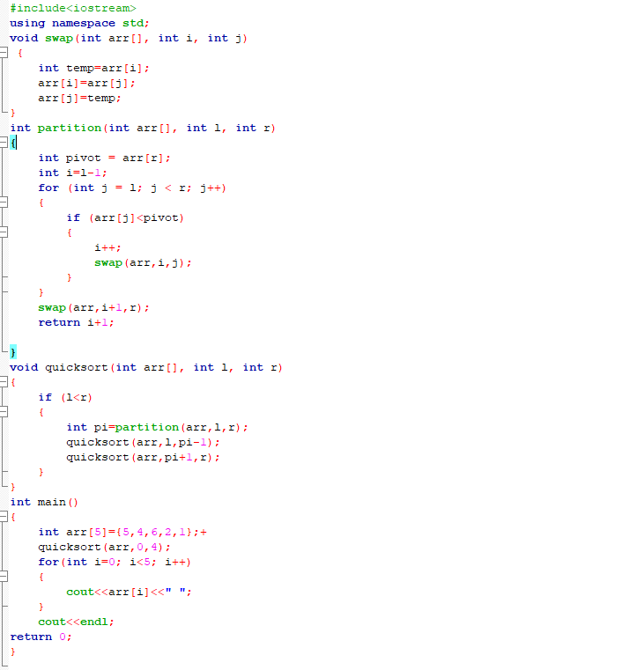

**Output:**

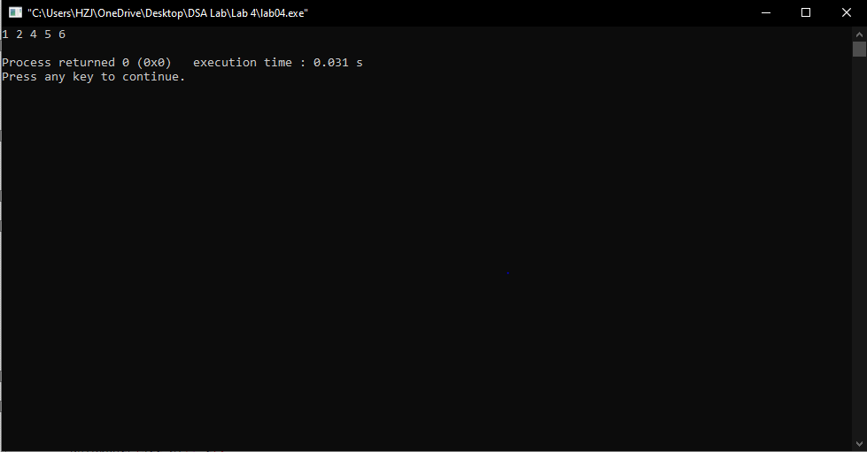

**Problem 2:**

**Solution:**

**Code:**

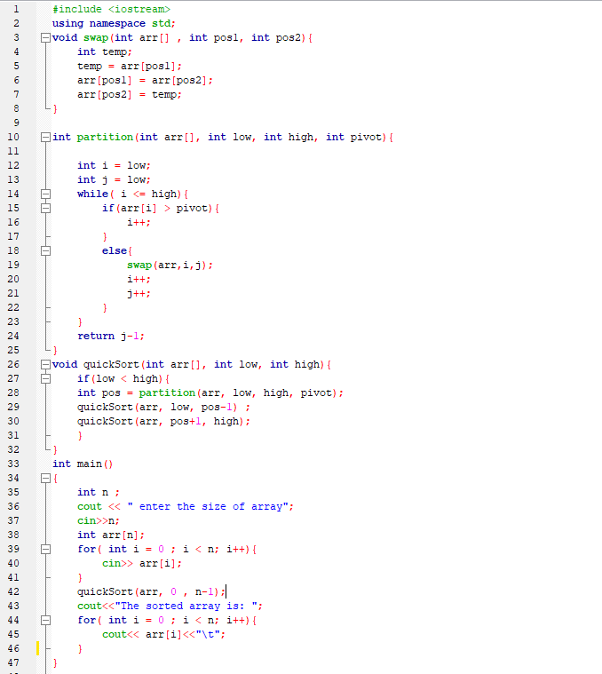

**Output:**

